Team meetings: Are our quality levels right?

Quality costs: whether it’s not fit for purpose, or whether it’s way beyond what customers want and expect (and are prepared to pay for), quality costs.

So it’s important that the team is aware of the interplay between quality and cost.

What we provide has to be fit for purpose, and it has to meet customer expectations. But customer expectations vary – often according to the price they pay. Do you expect the same level of service, environment and ambience in McDonalds, as you would in a 5 star restaurant? Look at the finish of the wood on a piece of antiques furniture, and compare it to the roof trusses in your loft. They’re both fit for purpose!

If a food outlet provided 5 star service at McDonalds prices, they’d be out of business very quickly. Very popular whilst they lasted, but very insolvent! If a roofing business finished their wood to furniture standards they wouldn’t last long either.

At the other extreme, if quality levels are too low, we have to do rework to put the mistakes right, and it always costs more to do a job twice!

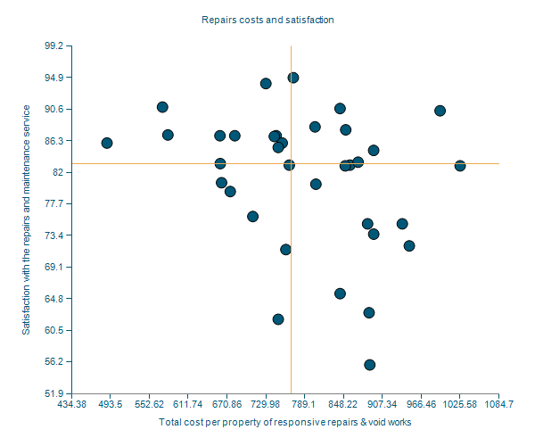
Weighing up the balance
The following scatter chart comes from a housing association’s benchmarking report. It shows the cost per property of responsive repairs for a number of housing associations along the bottom axis, and customer satisfaction (a measurement of perception of quality) up the vertical axis.

As a discussion question in a team meeting, which associations are doing best? How are the team evaluating “best” in terms of the correlation of quality and cost?

Fit for purpose?
It’s easy to strive for “always better”, but the search for perfection is futile. In the things your team does, how would you measure “good enough”, or “fit for purpose”? How do you decide how far above that line you should be delivering (to give an adequate safety margin), and in which circumstances you should be going further?

Not good enough?
Can your team identify the areas where quality isn’t good enough? These are important areas to identify, as having to re-do work pushes our costs up, and threatens our budgets. So we need to know where the problems are.

Too good?
The perfectionists on your team (maybe you’re one of them!) will argue that something can never be good enough. It can always be improved. True, it can always be improved, but often that improvement serves no purpose. And improving one thing means we can’t do the next thing at all.

So can your team identify areas where things are being done too well? Identifying these areas allows us to release some resources to use elsewhere.

Preparing for this team meeting
The key to this discussion is focus, and data. You’ll want to focus on your key tasks. The 80:20 rule often applies, so which 20% of tasks take up 80% of your team’s time and budget? focus the discussion around those areas.

Do you have any data about quality in those areas? Feedback, complaints, quality test results, customer returns, or anything else? If not, an additional team question might be around “How can we gather data that will tell us about quality?”

